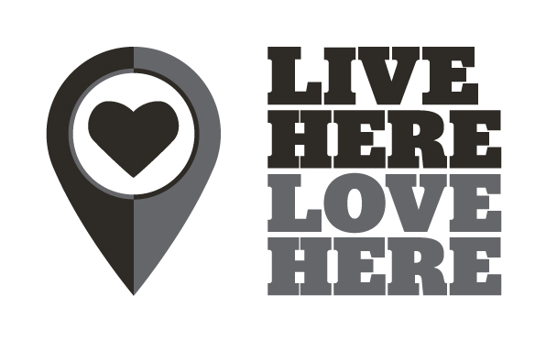

Small Grants Scheme 2018
Application Guidance Notes

Live Here Love Here is managed by Keep Northern Ireland Beautiful. If you have any queries in relation to the programme please contact the team at Keep Northern Ireland Beautiful.
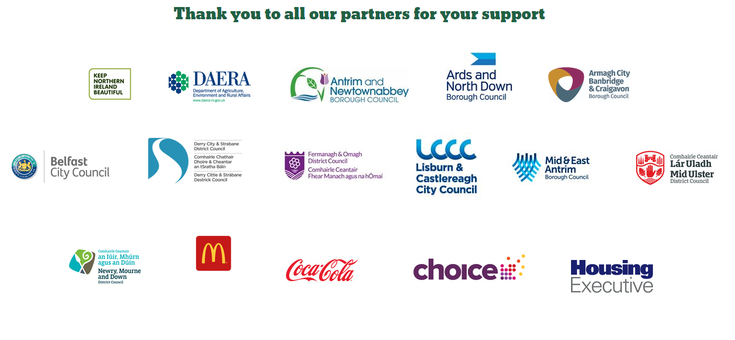

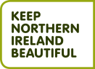
Keep Northern Ireland Beautiful
Phone: 028 9073 6920
Email: smallgrants@liveherelovehere.org
Web: www.liveherelovehere.org
The Live Here Love Here Small Grants Scheme forms part of a wider programme aimed at promoting civic pride within communities and improving environmental quality. The Small Grants Scheme is a partnership between Local Councils, Choice Housing, Northern Ireland Housing Executive, McDonald’s and Keep Northern Ireland Beautiful.

“Civic and community pride means taking our responsibilities as seriously as we value our rights. The result: we get out there and make our environment a better place to live.”

Ian Humphreys, Keep Northern Ireland Beautiful

The Small Grants Scheme aims to enable and support volunteers to:
- Improve the quality of their local environment by reducing littering and dog fouling through effective and innovative means;
- Enhance the environmental management of a local area;
- Contribute to the development of civic pride within a community with a focus on environmental improvement.

- Eligibility
The Live Here Love Here Small Grants Scheme is open to:
- Volunteer, community groups and NGOs
- All schools and third level education organisations
- Youth groups and sports clubs
- Not for Profit Organisations
To be eligible groups should be:
- Embedded in their local community,
- Primary aims and objectives focused on benefiting the community,
- Aim to reduce littering and dog fouling through effective and innovative means
Grants are available to all volunteers groups through the following partners:

- Antrim and Newtownabbey Borough Council
- Ards and North Down Borough Council
- Armagh City, Banbridge and Craigavon Borough Council
- Belfast City Council
- Derry City and Strabane District Council
- Fermanagh and Omagh District Council
- Lisburn and Castlereagh City Council
- Mid and East Antrim Borough Council
- Mid Ulster District Council
- Newry, Mourne and Down District Council
- Choice Housing (all Council areas)
- Northern Ireland Housing Executive (all Council areas)
- McDonald’s (all Council areas)

Value of Grants Awarded
Grants will be awarded between £500 and £5,000. Higher levels of funding are only likely to be awarded to outstanding projects.
The judging panel reserves the right to change funding bandings if required and the above is provided as a guide only. Please note: The total grant amount distributed to projects within a participating Partner area will be in proportion to the funding contribution made by that Partner to the scheme.
A group can make more than one application. There is no requirement for groups to obtain match funding for projects.
What type of projects will the scheme consider?
Proposed projects must engage volunteers and community groups to deliver practical action and must meet one or more of the following objectives:
- Improve the quality of their local environment;
- Reduce litter and/or dog fouling in their local environment through effective and innovative means;
- Develop the environmental management of a local area;
- Instil civic pride within a community provided the focus is on environmental improvement;
- Relate to environmental improvement in coastal areas or inland waterways;
Applicants should note that they do not need to meet all the objectives of Live Here Love Here; but in their application they should strongly indicate those objectives that they do meet.
The Small Grants Scheme is open to all groups including those which have previously received grants through the scheme. Partnership working is strongly encouraged.
Projects will be assessed in the following areas: environmental outcomes; project goals; project need; volunteer involvement; partnership working; long term impact; value for money and leverage.
What the scheme won’t fund
The primary focus of the Live Here Love Here Small Grants Scheme is to equip and support volunteers and community groups to deliver practical environmental action in their locality.
Some examples of items that the scheme will not fund:
- Translation
- Arts and crafts
- Murals
- Awareness-raising or communication projects (An element of communication, for example, a leaflet to promote a clean-up event, will be considered only if it is part of a wider project).
- Running costs for volunteer groups eg. Rent/ Insurance
- Salaries/Staff time
- Websites/Databases/Software
- Administration or project management fees
- Volunteer expenses
- Celebration events/parties
Site visits
During project delivery, Keep Northern Ireland Beautiful and/or other investing partners may contact participating groups to arrange site visits to monitor the progress of their project(s).

- The Application Process
Completed applications must be submitted to Keep Northern Ireland Beautiful by 12 noon on Monday 28th May
2018. Applications received after this deadline will not be considered
Please complete your application online at www.liveherelovehere.org
The online application is the preferred method for application but if you cannot complete this please download a Word version of the application form and email your completed application to: smallgrants@liveherelovehere.org
Alternatively, print and post to:
Small Grants Scheme
Keep Northern Ireland Beautiful
Bridge House, 2 Paulett Avenue
Belfast
BT5 4HD
Please note that proof of posting is not proof of receipt.
You will receive an email confirming receipt of your application and Keep Northern Ireland Beautiful will contact you directly when your application has been assessed within 4 weeks after the closing date.
Applicants must not change the format of the application form.
Please submit your completed application form in Word or PDF Format.
Additional documents will not be considered.

Timescale for Live Here Love Here Small Grants Scheme:
Funder | Deadline
Applications Submitted by | 12 noon on Monday 28th May 2018
Assessment completed and Letters of Offer sent | Friday 29th June 2018
Projects Completed & Financial Claims Submitted | 12 noon Monday 14th January 2019

- Claiming Your Grant
Partial payment of Grants will be available and funding will be released upon confirmation that elements of the project are complete. Groups should contact Keep Northern Ireland Beautiful if they expect to experience cash flow problems.*
All financial expenditure must take place and claim forms must be submitted to smallgrants@liveherelovehere.org by noon on 14th January 2019.
All purchases must have at least two written quotes (examples of online quotes will be accepted).
Failure to comply may result in grant funding being withheld or withdrawn.
Claim forms will be circulated to successful projects during July 2018.
*In exceptional circumstances partial payment of grants will be paid in advance (80% of funding upfront and the final 20% will be paid on receipt of a completed and satisfactory summary report), where groups paying for goods will create hardship. This will be assessed on a case by case basis and only where the relevant additional information has been supplied to Keep Northern Ireland Beautiful. A member of staff will be in touch to discuss details and to finalise the assessment.

