Live Here Love Here Combating Litter in Your Community Project Options
Innovative Project Title | Innovative Project Description
Vote with your Butt  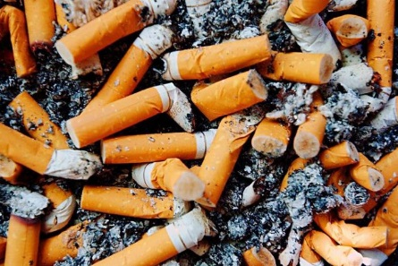 | Is cigarette litter an issue in your area? If so this inventive litter bin could help tackle the issue in a very visual way.  We have produced an ashtray bin that allows users to vote on topical issues such as Sports, Superheros or X-Factor results – whatever you choose! Smokers vote by placing their used cigarette butts into the bin rather than dropping them on the floor. These bins would be ideally placed where large numbers of people gather – pubs, clubs, transport hubs or outside office blocks.  Groups will be required to highlight the location of the bin, to monitor the use of the innovative bin and to keep the bin clean and maintained for the duration of the project.
We’re Watching You  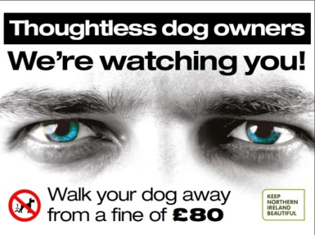 | The simplest way to maintain a clean community is to prevent littering and dog fouling in the first place.  We will provide high-quality, cost-effective poster and other artwork to deter unwanted behaviour and educate the wider public.  All posters are full colour and weather resistant. The posters can be moved frequently, preventing people from becoming accustomed to and then ignoring the message.  Groups will be required to highlight locations for the posters, to monitor the impact of the posters replacing any that become damaged for the duration of the project.
Footprints to the Bin  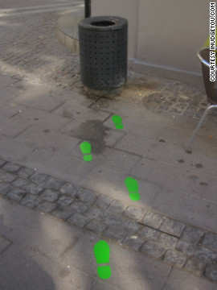 | Coloured footprints will be placed on the ground leading towards a bin to highlight and direct the public towards the nearest bin, thereby visually encouraging them to choose responsible litter disposal rather than littering.  This idea is not just about simply guiding people to the bin, but it’s about the roles of social norms, and making the right choice the easy choice.  Groups will be required to highlight locations for the footprints, to paint with special paint provided, to monitor the impact of the footprints and re-painitng any that become damaged for the duration of the project.

Localised Slogan Litter Bin | Fed up with littering in your area… Why not shout about it on a bin. Bins can be produced to share a witty slogan to encourage people to do the right thing. Keep Northern Ireland Beautiful can work with you to create some localised slogans that will work in your community.  Groups will be required to highlight locations for the bin, to select a suitable slogan, to monitor the impact of the bin and to empty it when required.
Fun Roadside Bin  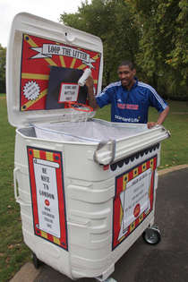 | Is roadside litter an issue blighting your community?  Tackle it with a fun roadside bin. Large industrial sized bins would be repurposed to create an element of fun for roadside use in notorious litter hot spots. The bins are large and may include targets or basketball hoops to encourage users who may have alternatively discarded litter out of windows. These bins can be moved to use in various locations.  Groups will be required to highlight locations for the bin, to select a suitable slogan, to monitor the impact of the bin and to contact the council whenever the bin needs emptied.

